**Kamerplanten in de winkel**

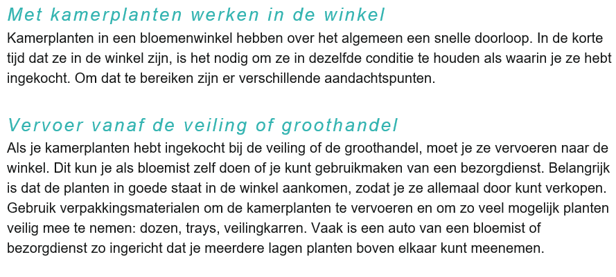

[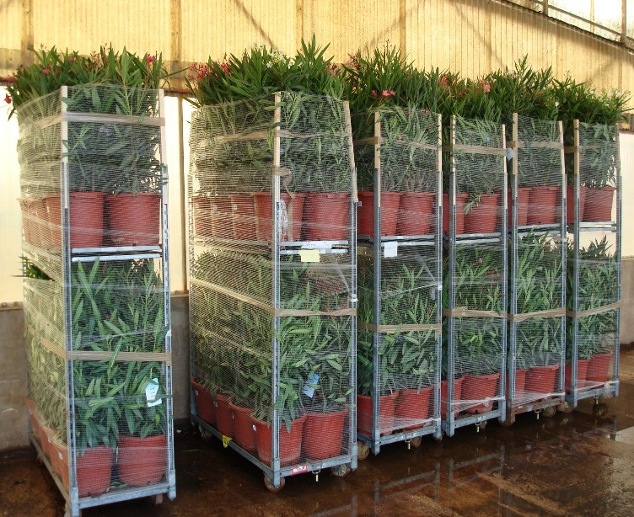](http://www.google.nl/url?sa=i&rct=j&q=&esrc=s&source=images&cd=&cad=rja&uact=8&ved=2ahUKEwjiweSXzqveAhXSCuwKHaRfCOcQjRx6BAgBEAU&url=http://www.mediterranova.nl/service.php&psig=AOvVaw3s_g2iKnAFKDtAmoX1v-5L&ust=1540901085192993)

